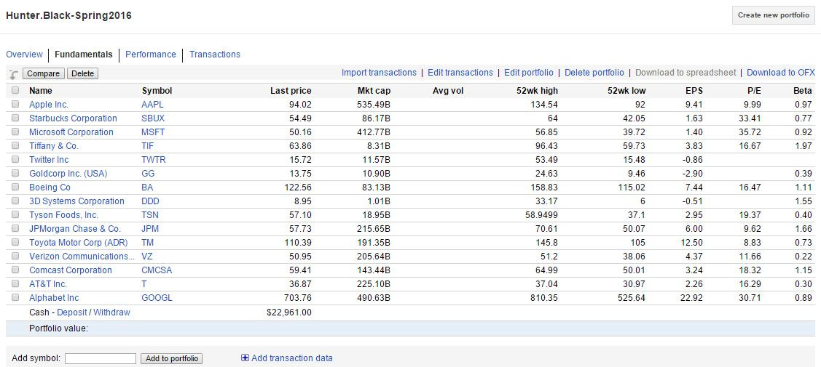**My portfolio:**

*I plan to watch JPMorgan, Toyota, Comcast, AT&T, and Alphabet as possible options in the future. All others I currently have shares in.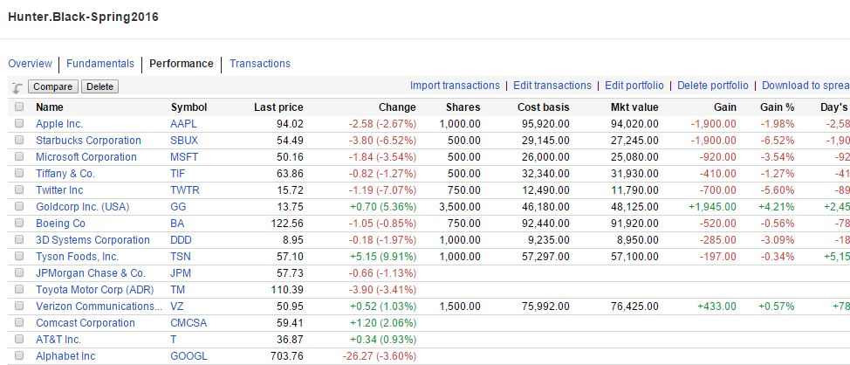

**Personal Evaluations:**

* **Apple**: I chose Apple because of the shear enormity of the company, seen by its market cap, and the fact that nearly everyone I know uses an Apple product every day. Additionally, Apple is coming out with the iPhone 7 soon, and with the ever changing nature of technology, to stay up to date nearly everyone has to “upgrade” their devices regularly
* **Starbucks**: I chose Starbucks because I personally drink a cup of Starbucks coffee every day, as does nearly everyone else in this nation. I do know that they are coming out with Starbucks Evenings soon, which I believe will boost their profits considerably
* **Microsoft**: Much like Apple, Microsoft is a company that has a hold on at least a single aspect of nearly everyone in the world, mainly seen through their OS Windows. I have always been an avid supporter of Microsoft and all that they do
* **Tiffany & Co**.: The main reason I chose to invest in Tiffany is because of the impending holiday (Valentines). After Valentines, I plan on evaluating their stocks and decide whether or not to sell this particular stocks
* **Twitter**: I use Twitter every day, multiple times. And I am willing to bet that if you ask anyone else, they do to. With the ever-rising popularity of social media and, coincidently, the rising popularity of expressing ideas in as few words as possible, I figured this would be a good investment
* **Goldcorp Inc**: I invested in the gold because I know that due to it being a limited raw material that has initial high value, gold is something that will, more often than not, always rise in price. I figured this would be my safest investment of them all, hence the large number of shares
* **Boeing**: My older brother works at the Boeing plant up in Seattle so I have some family ties to this company. I also believe it to be the more popular of the two when comparing it to Lockheed. I know that Boeing gets several business deals, not only in the US, but across seas as well
* **3D Systems Corporation**: I don’t know much about this company, but I do know that the industry (3D printing/products) is something that is becoming more popular as time passes, with 3D printed prosthetics, construction materials, and other such items becoming a cheap and easy alternative to other raw materials
* **Tyson Food Co**.: Tyson, the company that owns Jimmy Dean, BallPark, Wright, Hillshire Farm, and Aidells in the food industry. They have a low beta and have been on the rise in the last couple of months. I intend to watch this company carefully to insure I sell at a price that insures profit
* **Verizon**: This company has the lowest beta of all of the above companies, being the main reason I chose to invest. They have a long track-record of continually producing consistent profits, and I know many who use Verizon as their internet/TV/cellphone provider

**Monitoring my Portfolio**

* In order to monitor my portfolio and ensure that I make the most profit as possible, I intend to log onto my Google Finance at least once a day, making sales/purchases at least once a week if it appears I need to based on stocks doing extremely well/poorly. Overall, I want to improve my portfolios overall value by at least 10% over the period of this course. At the end of the day, I hope to learn which companies are profitable and if high-risk high-reward companies turn out to be worth it in the long run.